Project Design Phase
Solution Architecture

Date | 28 September 2026
Team ID | SWTID-2026-5152
Project Name | AI FitWell – AI Personalized Fitness, Wellness and Meals Planner
Maximum Marks | 4 Marks

Solution Architecture:
Solution architecture is a complex process – with many sub-processes – that bridges the gap between business problems and technology solutions. Its goals are to:
- Find the best tech solution to solve existing business problems.
- Describe the structure, characteristics, behavior, and other aspects of the software to project stakeholders.
- Define features, development phases, and solution requirements.
- Provide specifications according to which the solution is defined, managed, and delivered.

Solution Architecture Diagram – AI FitWell:

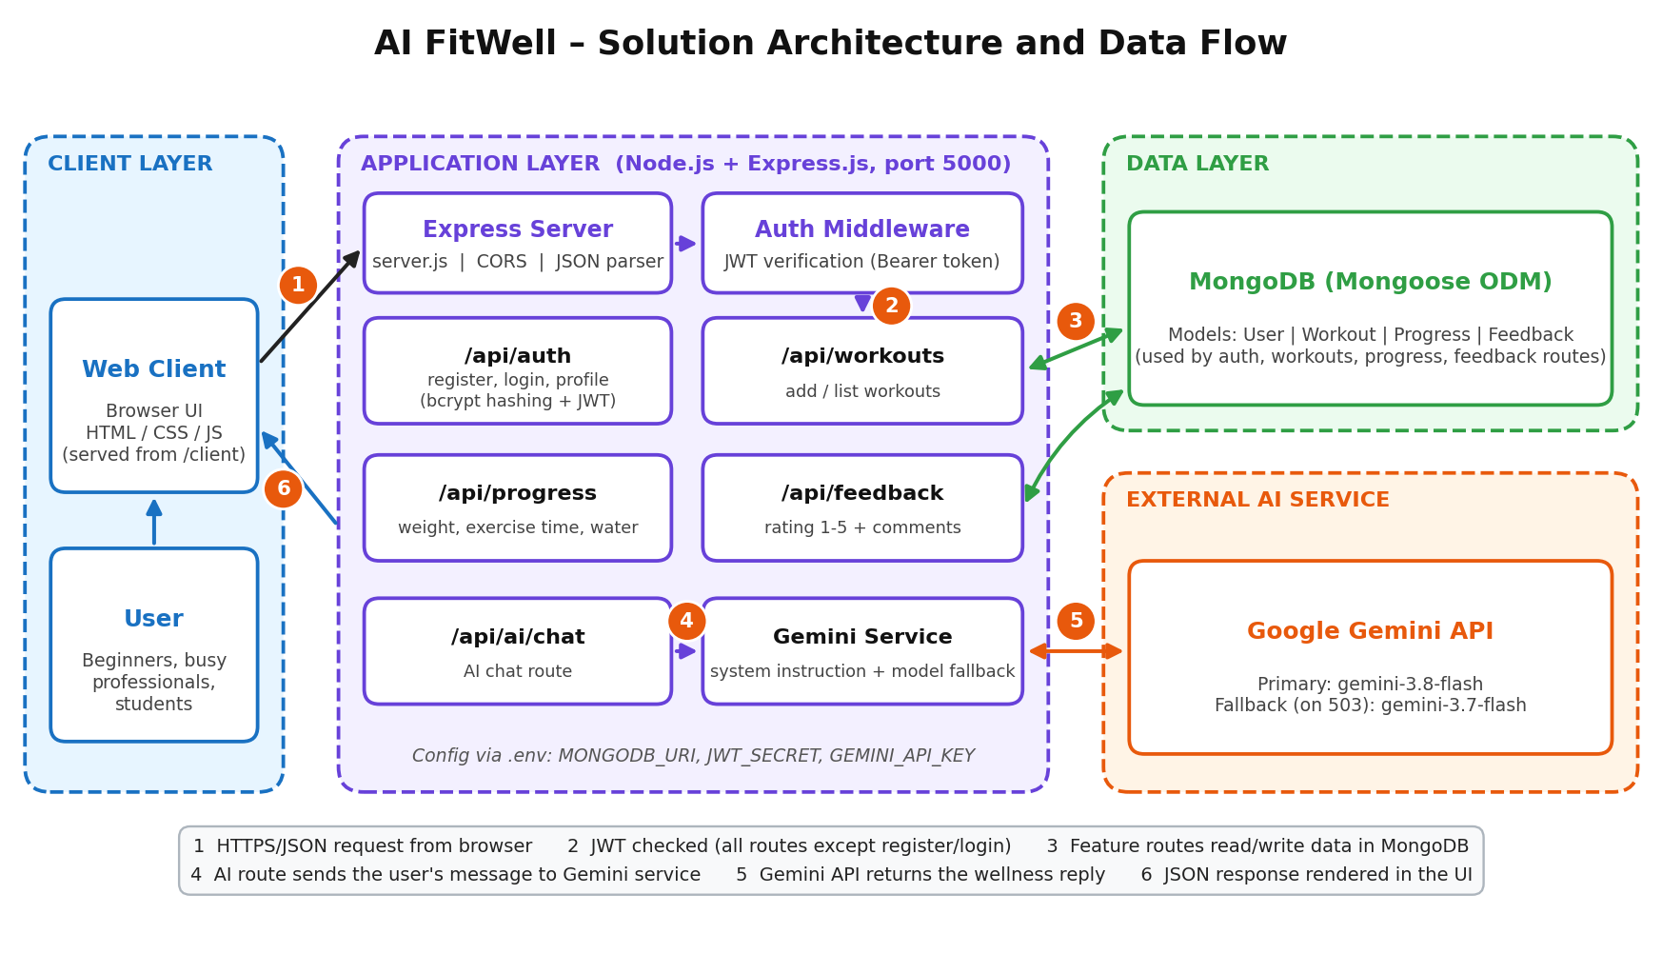
Figure 1: Architecture and data flow of the AI FitWell application
Components and Technology Stack:
Layer / Component | Technology | Role
Web Client (Client layer) | HTML, CSS, JavaScript (served from /client) | Browser UI where users register, log in, add workouts, log progress, chat with the AI assistant and give feedback.
API Server | Node.js, Express.js, CORS | Single REST API server (port 5000); parses JSON, serves the static client and exposes /api/auth, /api/workouts, /api/progress, /api/feedback and /api/ai.
Security | JWT, bcryptjs, auth middleware | Passwords are hashed with bcrypt; login issues a 1-day JWT; the middleware verifies the Bearer token so users can access only their own data.
Feature Routes | Express Router | Auth and profile, workout log, progress tracker (weight, exercise time, water), feedback (rating 1–5) and AI chat.
Database (Data layer) | MongoDB with Mongoose | Stores User, Workout, Progress and Feedback documents; records are linked to the user through userId.
AI Service | Google Gemini API (@google/genai) | Wellness assistant with a system instruction (no diagnosis); uses gemini-3.8-flash and falls back to gemini-3.7-flash when the model is busy (503).
Configuration | dotenv (.env) | Keeps MONGODB_URI, JWT_SECRET and GEMINI_API_KEY outside the source code.

Data Flow:
1. The user opens the web client and sends a request (register, login, add workout, save progress, feedback or AI chat) to the Express API as JSON.

2. For protected routes the auth middleware verifies the JWT; register and login are public and login returns the token.

3. The feature route validates the input and reads or writes the user's data in MongoDB through the Mongoose models.

4. For AI chat, the route passes the user's message to the Gemini service, which adds the wellness system instruction.

5. The Gemini API returns the reply (with automatic fallback to the alternate model if the primary model is busy).

6. The server sends a JSON response back and the client displays it to the user.

